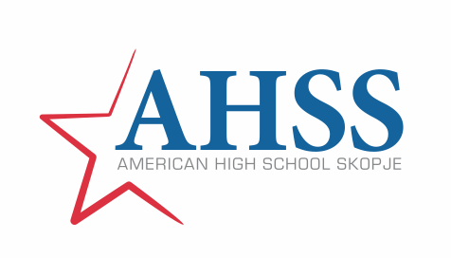

Based on Article 3 of the Rulebook for determining the criteria and manner of declaring a student of the generation and for praising and rewarding students who have shown exceptional results in the educational process, the Commission for Praise and Awards of the American High School Skopje, on April 8, 2026, announces

OPEN CALL
FOR SELECTION OF STUDENT OF THE GENERATION 2022/2026
AMERICAN HIGH SCHOOL SKOPJE

- GENERAL INFORMATION

In order to highlight students who have shown exceptional results in the educational process throughout all four academic years, and in accordance with the applicable internal regulations, the American High School Skopje declares a student of the generation, for which it announces an Open Call for the selection of a student of the generation 2022/2026.

The call is open to all Grade 12 students at the American High School Skopje.

A candidate for a student of the generation can be proposed by the Homeroom teacher, the subject teacher and any student who believes that he/she or another student meets the conditions specified in the criteria for the selection of a student of the generation.

- REQUIRED DOCUMENTS FOR APPLICATION

- Аpplication for selection of student of the generation
- Short biography with listed curricular and extracurricular activities and events
- Copies of municipal, regional, national and international awards from competitions
- Copies of diplomas, certificates of appreciation, letters of thanks, etc.

Written proof of success at the end of each academic year (certificates and Official Transcripts) for each registered candidate is provided by the commission ex officio.
The application, together with the documents, is submitted to the commission through the High School archive.

Registration for the competition will last until May 8, 2026.

- CRITERIA FOR SELECTING A STUDENT OF THE GENERATION

The ranking of candidates will be done according to the table below:
Criteria | Maximum %
Average GPA in all years* | 40
Class Attendance | 10
Participation in competitions and awards won | 20
Participation in the student community  - Student Council  - Class | 10
Participation in school (curricular and extracurricular) activities and events planned in the annual school program | 20

* Candidates must have a grade point average of 5.00 at the end of the academic year, i.e. 4 GPA, in each of the four years.

** In the event that the candidate has more than 7 unexcused absences in all four years, as well as in the event that the candidate has been given a pedagogical measure on any basis during all four years of schooling at the School or has not respected the Code of Ethical Conduct, the candidate will be disqualified.

***If several candidates on the ranking list have the same number of points, the candidates' work grades during all four school years are taken into account.

Members of the Commission:
Milosh Andonovski, President

________________________________________

Kristiana Shijakova, Member

________________________________________

Sandra Nakova, Member

_________________________________________

